Programmer Says Game

Definition of Programmer says game

If..then is basic statement for coding, The program queries if there is a condition and then instructs it to perform certain operations. It can be as basic as a true or false question and answer, or it can prompt for action.

For each game begin, One child will play the programmer and the other child will play the computers, the programmer will order to all computers “If I ____ (fill in the blank), then you _____ (fill in the blank)”. For example, the Programmer below gave the command “**If** I turn in a circle, **Then** you turn in a circle.”

Game in progress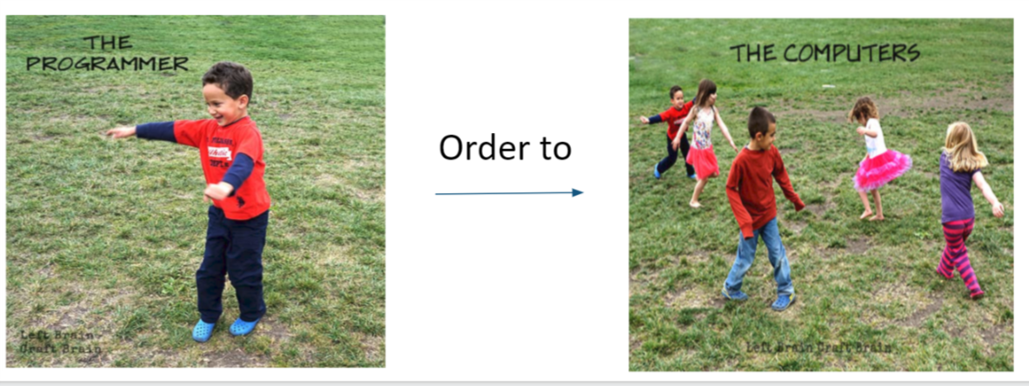

Type of Programmer says game

For this activity, multiple children are required to play together. Each round of the game will have different children to play the programmer (the one who gives orders). The difference in difficulty level will depend on the age of the children participating in the game (generally 3-8 years old).

|  |  |  |
| --- | --- | --- |
| Difficulty Level | Environment to play | Brief description |
| Level 1 | If I do this, then you do this. | The Programmer commands the Computers to do the same thing she does and to stop when she stops. |
| Level 2 | If I do this, then you do that. | add the twist that the Computers should do something different than the Programmer, but still start and stop when they do. This one works the brain because they’ll hear something different than they are seeing. |
| Level 3 | If I do this, then you do that, else you do something else. | the Programmer commands “If I raise my right arm, Then you raise your left arm, Else raise your right foot.” So if he just stands there and does nothing, the Computers should all be raising their right foot.  This gets pretty funny, pretty fast. |
| Level 4 | If..Then…Else Speed Round with eliminations. | Have the Computers “break” and sit down when they don’t follow commands correctly. The last Computer standing wins. |

(NOVEMBER 1, 2018 BY LEFTBRAINCRAFTBRAIN)

Two stages of STEM education

The STEM education begins when learners are young to create better results because young children are easy to use. This event consists of 2 different stages.

|  |  |  |
| --- | --- | --- |
| Stage | STEM teaching content | Expected Outcome |
| Kindergartner | Programmer’s player order to computer’s player to do the same thing he does and to stop when he stops. | Children can feel the fun of the game and are willing to participate, and learning simple coding in the game. |
| Primary school | Make more complex games, such as adding a statement from If-Then-Else. | To Understand more complicated rules |

General goal: Help your child learn the most basic programming knowledge in the game, improve their interest, exercise their brain and responsiveness.

Preparation: a playground.

Confirm target participants

The reason why selects beginning level is:

1. Younger children can also understand the rules of the game.
2. The fun of children is cultivated in the form of games, because children are not willing to try boring things.
3. For children who play programer, they can improve their organizational skills, and children who play computers can exercise their coordination skills.